**TRIBHUVAN UNIVERSITY**

**INSTITUTE OF ENGINEERING**

**Lab Sheet #7**

**PURWANCHAL CAMPUS**

DHARAN-8

**Submitted by:** **Submitted to:**

Name: **Arbind Kumar Mehta** Department of

Roll No: **PUR075BCT017** Electronics & Computer

Faculty: BCT Engineering

Group: I/I ‘A’

Date: ….......................... Checked by: ……………………….

**Title:**

Write a program to find separately the sum of the positive and negative integer elements of an array of size 10. Pass this array to a function called sortarray(int[]) and display the array elements into ascending order.

**Objective:**

* To understand the programming using Loop & nested loop Statements (for, while, do-while) and functions in C.

**Problem Analysis:**

Based on problem, it is required to define a array and four integer variable. Different operation should performed using user defined function.

|  |  |  |
| --- | --- | --- |
| **Input variables** | **Output variables** | **Necessary header files/functions/macros** |
| a[10],j,i(int type) | Sum1,sum2(int type) | stdio.h  coino.h  scanf()  printf()  math.h  display()  read()  sortarray() |

**Algorithm:**

1. Start
2. Define variables: a[]
3. Print:sortarray
4. Stop

**Flowchart:**

Start

Define variable: a[10],I,j,sum1,sum2

Read:a[]

End

Print:sortarray

**Code:**

#include <stdio.h>

#include <stdlib.h>

void read(int a[])

{

int i;

for(i=0;i<10;i++)

{

scanf("%d",&a[i]);

}

}

void display(int a[])

{

int i;

for(i=0;i<10;i++)

{

printf("%d ",a[i]);

}

}

void sortarray(int a[])

{

int i,j,temp;

for(i=0;i<10-1;i++)

{

for(j=i+1;j<10;j++)

{

if(a[i]>a[j])

{

temp=a[i];

a[i]=a[j];

a[j]=temp;

}

}

printf("%d ",a[i]);

}

}

int main()

{

int a[10],i,j,sum1=0,sum2=0;

printf("Enter the element(integer) of array:\n");

read(a);

printf("The array is:\n");

display(a);

for(i=0;i<10;i++)

{

if(a[i]<0)

sum1=sum1-a[i];

else

sum2=sum2+a[i];

}

printf("\nThe sum of positive and negative element of given array are %d and -%d respectively.\n",sum2,sum1);

printf("The sorted array is:");

sortarray(a);

return 0;

}

**Output (Compilation, Debugging and Testing):**

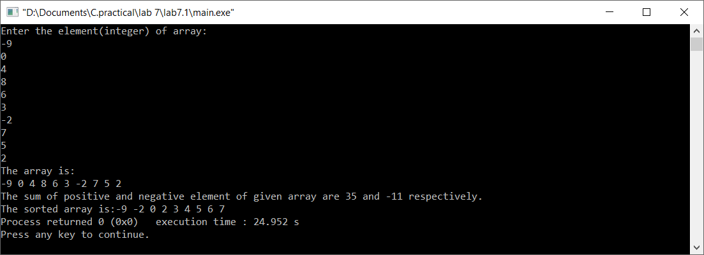

**Discussion & Conclusion:**

In this lab of C programming, based on the focused objective(s) to understand about C data types with formatted input/output functions with user defined functions.

**Title:**

Write a program to enter 10 floating numbers in an array and display it.

**Objective:**

* To understand the programming using Loop & nested loop Statements (for, while, do-while) and to be familier with array operation in C.

**Problem Analysis:**

Based on problem, it is required to define one integer variable and one floating array of size 10. Different operation should performed using for loop.

|  |  |
| --- | --- |
| **Input variables** | **Necessary header files/functions/macros** |
| i(int type)  a[10](float) | stdio.h  coino.h  scanf()  printf() |

**Algorithm:**

1. Start
2. Define :a[],i
3. Read:a[]
4. print: a[]
5. Stop

**Flowchart:**

Start

Define:I,a[10]

Read:a[]

Print:a[]

End

**Code:**

#include <stdio.h>

#include <stdlib.h>

int main()

{

float a[10];

int i;

printf("Enter the element(float) of array:\n");

for(i=0;i<10;i++)

{

scanf("%f",&a[i]);

}

printf("The array is:\n");

for(i=0;i<10;i++)

{

printf("%.2f ",a[i]);

}

return 0;

}

**Output (Compilation, Debugging and Testing):**

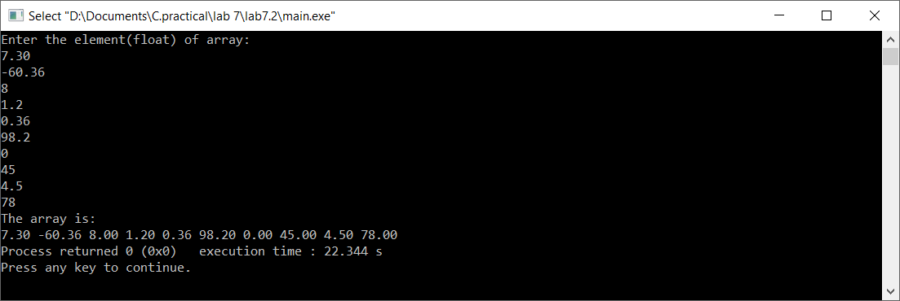

**Discussion & Conclusion:**

In this lab of C programming, based on the focused objective(s) to understand array operations in C.

**Title:**

Write a program to initialize one dimensional array of size 8 and display the sum and average of array elements

**Objective:**

* To understand the use of functions and array operation in C.

**Problem Analysis:**

Based on problem, it is required to define three integer variable and two float variables. Different operation are performed using for loop.

|  |  |
| --- | --- |
| **Input variables** | **Necessary header files/functions/macros** |
| I,j,a[8](int type)  Avg,sum(float type) | stdio.h  coino.h  scanf()  printf() |

**Algorithm:**

1. Start
2. Define variables: avg, sum,I,j,a[8]
3. Read:a[]
4. Print:avg,sum
5. Stop

**Flowchart:**

Start

Define variable:avg,sum,I,j,a[8]

Print:avg,sum

End

**Code:**

#include <stdio.h>

#include <stdlib.h>

int main()

{

float avg,sum=0;

int j,i,a[8];

printf("Enter the element(integer) of array:\n");

for(i=0;i<8;i++)

{

scanf("%d",&a[i]);

}

printf("The array is:\n");

for(i=0;i<8;i++)

{

printf("%d ",a[i]);

}

for(i=0;i<8;i++)

{

sum=sum+a[i];

}

avg=(float)(sum/8);

printf("\nThe sum of element is %.1f and average is: %.2f",sum,avg);

return 0;

}

**Output (Compilation, Debugging and Testing):**

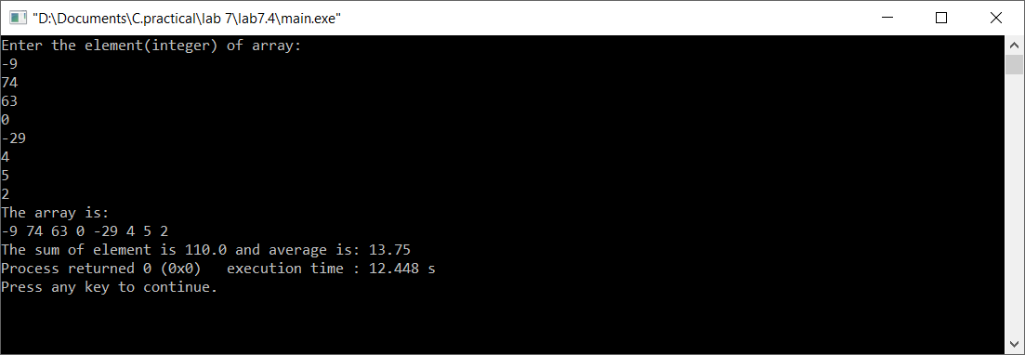

**Discussion & Conclusion:**

In this lab of C programming, based on the focused objective(s) to understand array operations in C.

**Title:**

Write a program to read two matrices of order 3 * 2, add them and display the resultant matrix in matrix form.

**Objective:**

* To understand the programming using for loop and array operations in C.

**Problem Analysis:**

Based on problem, it is required to define five integer variable and two array of size [3][2]. Different operation should performed using if statement.

|  |  |
| --- | --- |
| **Input variables** | **Necessary header files/functions/macros** |
| a[3][2],b[3][2],j,k,i,sum[3][2] (int type) | stdio.h  coino.h  scanf()  printf() |

**Algorithm:**

1. Start
2. Define variables: a[3][2],b[3][2],j,k,i,sum[3][2]
3. Read:a[]
4. Print:sum[]
5. Stop

**Flowchart:**

Start

Define variable: a[3][2],b[3][2],j,k,i,sum[3][2]

Read variable: a[]

Print:sum[]

End

**Code:**

#include <stdio.h>

#include <stdlib.h>

int main()

{

int a[3][2],b[3][2],j,k,i,sum[3][2];

printf("Enter the first row wise matrix:\n");

for(i=0;i<3;i++)

{

for(j=0;j<2;j++)

{

scanf("%d",&a[i][j]);

}

printf("\n");

}

printf("Enter the second row wise matrix:\n");

for(i=0;i<3;i++)

{

for(j=0;j<2;j++)

{

scanf("%d",&b[i][j]);

}

printf("\n");

}

printf("The sum of matrix:\n");

for(i=0;i<3;i++)

{

for(j=0;j<2;j++)

{

printf("%d\t",a[i][j]+b[i][j]);

}

printf("\n");

}

getch();

return 0;

}

**Output (Compilation, Debugging and Testing):**

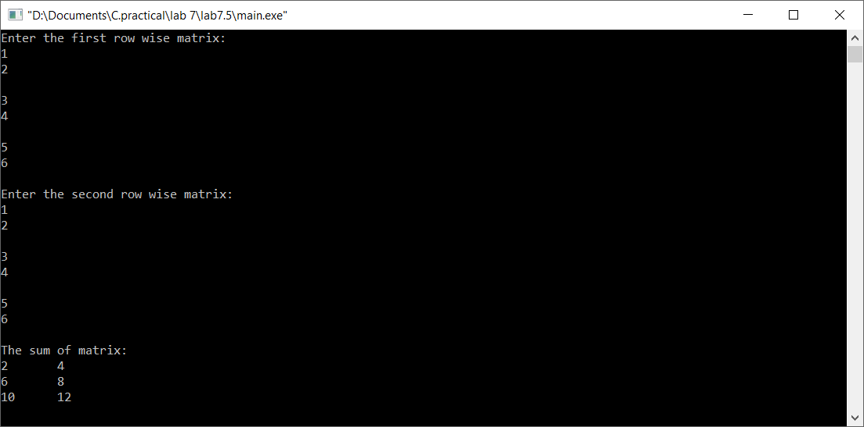

**Discussion & Conclusion:**

In this lab of C programming, based on the focused objective(s) to understand use of for loop and array operation in C.

**Title:**

Write a program to multiply two 3*3 matrix.

**Objective:**

* To understand the programming using array operation, for loop and if statement in C.

**Problem Analysis:**

Based on problem, it is required to define two array of type integer. Different operation should performed using if statement and for loop.

|  |  |
| --- | --- |
| **Input variables** | **Necessary header files/functions/macros** |
| m1[5][5],m2[5][5],c1,r1,c2,r2,i,j,k,x=0 (int type) | stdio.h  coino.h  printf() |

**Algorithm:**

1. Start
2. Define variables: m1[5][5],m2[5][5],c1,r1,c2,r2,i,j,k,x=0
3. Read: r1,c1,r2,c2,m1[][],m2[][]
4. Print: x+=(m1[i][k]*m2[k][j])
5. Stop

**Flowchart:**

Start

Define variable: m1[5][5],m2[5][5],c1,r1,c2,r2,i,j,k,x=0;

Read: r1,c1,r2,c2,m1[][],m2[][]

Print: x+=(m1[i][k]*m2[k][j])

End

**Code:**

#include <stdio.h>

#include <stdlib.h>

int main()

{

int m1[5][5],m2[5][5],c1,r1,c2,r2,i,j,k,x=0;

printf("Enter the order of first matrix in the range of 5:\n");

scanf("%d%d",&r1,&c1);

printf("Enter the order of second matrix in the range of 5:\n");

scanf("%d%d",&r2,&c2);

if(c1!=r2)

{

printf("Multiplication is not possible!!!");

exit(0);

}

printf("Enter first matrix:\n");

for(i=0;i<r1;i++)

{

for(j=0;j<c1;j++)

{

scanf("%d",&m1[i][j]);

}

}

printf("Enter second matrix:\n");

for(i=0;i<r2;i++)

{

for(j=0;j<c2;j++)

{

scanf("%d",&m2[i][j]);

}

}

printf("The matrices are:\n");

for(i=0;i<r1;i++)

{

for(j=0;j<c1;j++)

{

printf("%d\t",m1[i][j]);

}

printf("\n");

}

printf("&\n");

for(i=0;i<r2;i++)

{

for(j=0;j<c2;j++)

{

printf("%d\t",m2[i][j]);

}

printf("\n");

}

printf("The product matrix is:\n");

for(i=0;i<r1;i++)

{

for(j=0;j<c2;j++)

{

for(k=0;k<c1;k++)

{

x+=(m1[i][k]*m2[k][j]);

}

printf("%d\t",x);

x=0;

}

printf("\n");

}

getch();

}

**Output (Compilation, Debugging and Testing):**

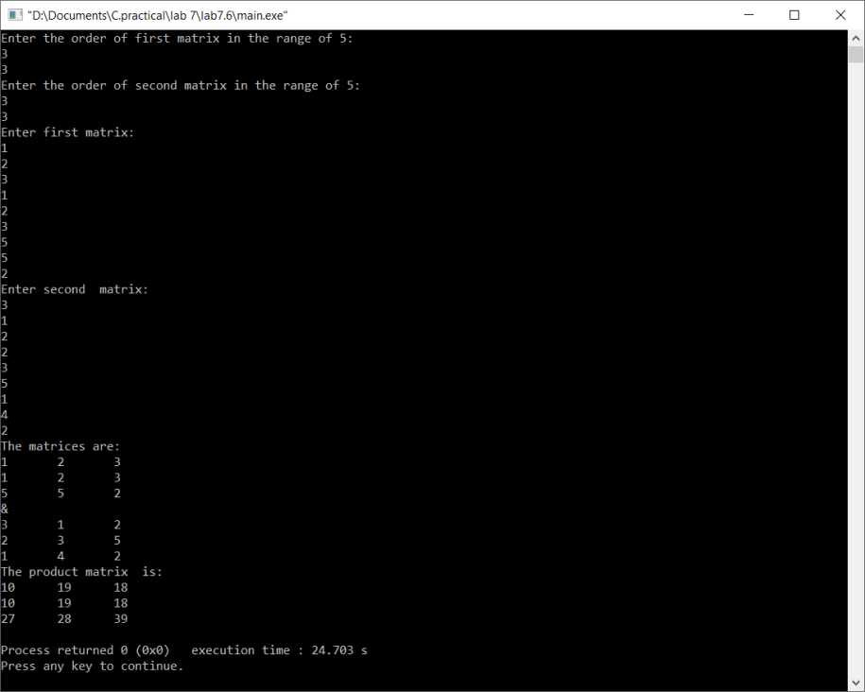

**Discussion & Conclusion:**

In this lab of C programming, based on the focused objective(s) to understand about C data types with use for loop and array operations in C.

**Title:**

Write a program to read a string and check for palindrome without using string related function

**Objective:**

* To understand use of for loop, if statement and array operation in C.

**Problem Analysis:**

Based on problem, it is required to define four integer and one character variables. Different array operation should perform using for loop and if statement in C.

**Algorithm:**

1. Start
2. Define variables: ch[],len,j,I,flag=0
3. Read:ch[]

len=strlen(ch);

for(i=0;i<(len/2);i++)

{

if(ch[i]!=ch[len-1])

{

flag=1;

}

len--;

}

1. Print:

if(flag==1)

printf("\n%s is not palidrome!!!",ch);

if(flag==0)

printf("\n%s is palidrome",ch);

1. Stop

**Flowchart:**

Start

Define variable: ch[],len,j,I,flag=0

Read: ch[]

Print: ch[]

End

**Code:**

#include <stdio.h>

#include <string.h>

int main()

{

char ch[100];

int len,i,j,flag=0;

printf("Enter string:");

gets(ch);

len=strlen(ch);

for(i=0;i<(len/2);i++)

{

if(ch[i]!=ch[len-1])

{

flag=1;

}

len--;

}

if(flag==1)

printf("\n%s is not palidrome!!!",ch);

if(flag==0)

printf("\n%s is palidrome",ch);

return 0;

}

**Output (Compilation, Debugging and Testing):**

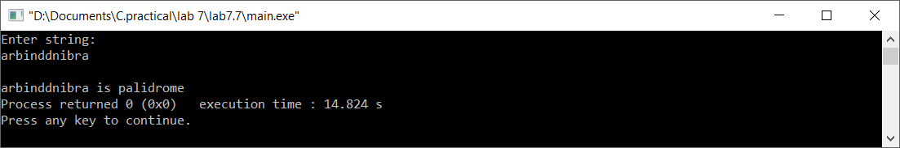

**Discussion & Conclusion:**

In this lab of C programming, based on the focused objective(s) to array operation, uses of for loop and if statement in C.

***